H.T No
Regulations:
A20

Sreenidhi Institute of Science and Technology
(An Autonomous Institution)
Code No:8HC13 Date:13 -August-2024 (FN)

B.Tech I-Year II- Semester External Examination, August-2024 (Supplementary)
DIFFERENTIAL CALCULUS AND NUMERICAL METHODS (CSE, CS, AI&ML, DS, IOT, IT and ECM)

Time: 3 Hours Max.Marks:70

Note: a) No additional answer sheets will be provided.
b) All sub-parts of a question must be answered at one place only, otherwise it will not be valued.
c) Missing data can be assumed suitably.

Bloom's Cognitive Levels of Learning (BCLL)

Remember | L1 | Apply | L3 | Evaluate | L5
Understand | L2 | Analyze | L4 | Create | L6

Part - A Max.Marks:20
Answer all QUESTIONS

 |  | BCLL | CO(s) | Marks
1 | Solve 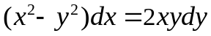 | L2 | CO1 | [2M]
2 | Find the particular integral of 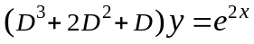 | L2 | CO2 | [2M]
3 | If 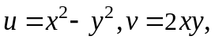find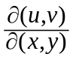 | L2 | CO3 | [2M]
4 | Evaluate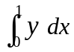by Trapezoidal rule, given that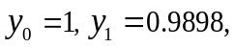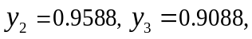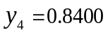and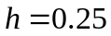 | L1 | CO4 | [2M]
5 | Evaluate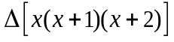by taking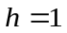 | L1 | CO5 | [2M]
6 | Using Euler’s method find an approximate value of 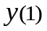given that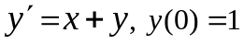 | L2 | CO6 | [2M]
7 | Solve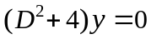 | L2 | CO2 | [2M]
8 | Find a unit vector normal to the surface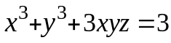 at the point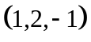 | L2 | CO3 | [2M]
9 | Evaluate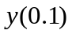by Taylor’s series method from 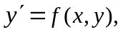 given that 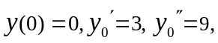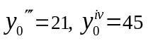 correct to 3 decimals | L1 | CO6 | [2M]
10 | Find an integrating factor of the differential equation 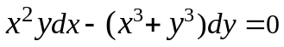 | L2 | CO1 | [2M]
Part – B Max.Marks:50
ANSWER ANY FIVE QUESTIONS. EACH QUESTION CARRIES 10 MARKS.

 |  |  | BCLL | CO(s) | Marks
11. | a) | Solve | L3 | CO1 | [5M]
 | b) | If the temperature of air is 30°C and the substance cools from 100°C to 70°C in 15 minutes, find when the temperature will be 40°C. | L3 | CO1 | [5M]
12. |  | Solve 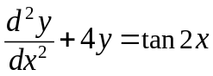 by the method of variation of parameters | L3 | CO2 | [10M]
13. | a) | Find the minimum and maximum values of the function 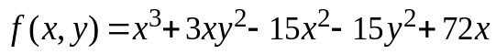 | L3 | CO3 | [5M]
 | b) | Find the directional derivative of 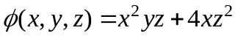at the point 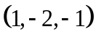 in the direction of the vector 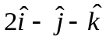 | L3 | CO3 | [5M]
14. | a) | Use Newton-Raphson method to find the real root of the equation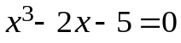 correct to four decimal places | L3 | CO4 | [5M]
 | b) | Use Simpsons 1/3rd rule to find 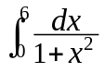 correct to four decimals | L3 | CO4 | [5M]
15. |  | From the following data, find the value of y(0.12) and 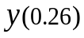 using Newton’s forward and backward interpolation formulae. | L3 | CO5 | [10M]
   | 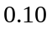 | 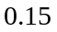 | 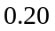 | 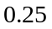 | 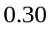
   | 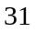 | 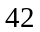 | 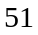 | 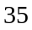
16. |  | Use Runga-Kutta method of fourth order to evaluate y(0.1) given that 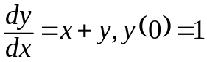 | L3 | CO6 | [10M]
17. | a) | Solve 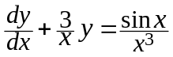 | L3 | CO1 | [4M]
 | b) | Solve 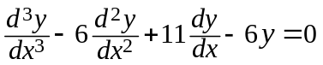 | L3 | CO2 | [3M]
 | c) | If 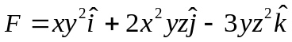 find 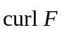at 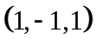 | L3 | CO3 | [3M]
18. | a) | Evaluate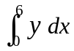by Simpson’s 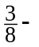rule Given that 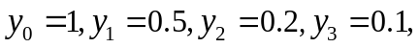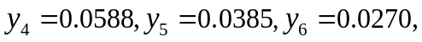and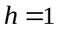 | L3 | CO4 | [4M]
 | b) | Using Gauss’s forward interpolation formula, find 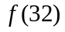 given that 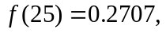 | L3 | CO5 | [3M]
 | c) | Obtain first approximate solution of the equation 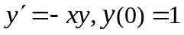 by Picard’s method | L3 | CO6 | [3M]
-- 00 -- 00 –

